

**World Trade Center Portland**

**Tenant Handbook**

February 2025

Welcome

## Welcome to the World Trade Center Portland! We are delighted to have you as part of our community. This Tenant Handbook is designed to assist you during your move-in process and throughout your tenancy. We hope it will address many of your questions and provide valuable insights into our facilities and services.

## The information in this handbook is intended to help you better understand the World Trade Center Portland and support your company’s operations. Should you have any questions or require assistance, please do not hesitate to contact the Management Office. We are here to help and will ensure you receive the support you need.

## For additional information and forms, please visit our website: [www.wtcpdx.com](http://www.wtcpdx.com/)

## Management Office Contact Information:

## Phone: 503-464-7527

## Address: One World Trade Center, 121 SW Salmon Street, Suite 230, Portland, OR 97204

## Management Team:

## Dyann Bernatz, Executive Director, Dyann.Bernatz@pgn.com

## Paul Wallman, Facilities Manager, Paul.Wallman@pgn.com

## Sumandhi Fox, Property Manager, Sumandhi.fox@pgn.com

## Erin McConkey, Sr. Operations Coordinator, Erin.McConkey@pgn.com

## Ronaldo Villanueva, Chief Engineer, Ronaldo.Villanueva@pgn.com

## We strive to provide current and accurate information in this handbook, but please note that some details may change over time. The Management Office will promptly notify you of any updates or changes. Should you have any questions, feel free to contact us at any time. We are here to serve you.

## Once again, welcome to the World Trade Center Portland. We look forward to supporting your success and ensuring your tenancy is enjoyable and productive.

## History

## In 1975, as part of a revitalization strategy initiated by the City of Portland to rejuvenate the waterfront area, the Portland General Electric Company developed a three-building complex known as the “Willamette Center.” Construction was completed in 1977.

## In 1987, the Willamette Center won a city-wide competition to become the designated location of the newly formed Oregon Trade and Marketing Center, created by the State of Oregon. To reflect its new status and mission, the complex was officially renamed the “World Trade Center” on June 29, 1988.

## The World Trade Center Association (WTCA) is a not-for-profit, non-political organization dedicated to establishing and operating World Trade Centers as instruments for international trade expansion. The WTCA represents 322 members in more than 90 countries, fostering global commerce and connecting businesses worldwide.

**Bike Hub**

A dedicated bicycle hub is conveniently located on the P2 level of the World Trade Center parking garage, providing a secure and accessible space for tenants. The hub features secured day-use lockers, ample bicycle racks, and showers, all available at no charge to building occupants.

World Trade Center tenants can access the bicycle hub using their building ID badge. To sign up:

1. Complete the required forms:

* [Release of Liability](https://wtcpdx.com/wp-content/uploads/2021/06/2022-WTC-Fitness-Facilities-Release-of-Liability-Final.pdf)
* [Rules and Regulations](https://wtcpdx.com/wp-content/uploads/2021/06/2022-WTC-Fitness-Facilities-Rules-Regulations-Final.pdf)

1. Submit the Forms: Sign and return the completed forms to [erin.mcconkey@pgn.com](mailto:erin.mcconkey@pgn.com) to activate your ID badge for access

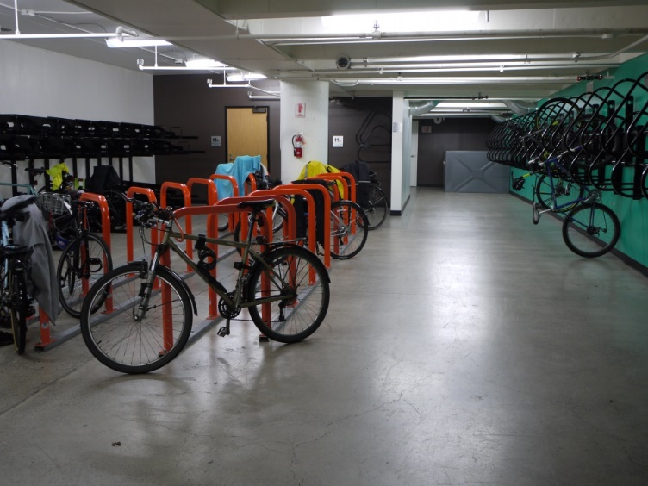

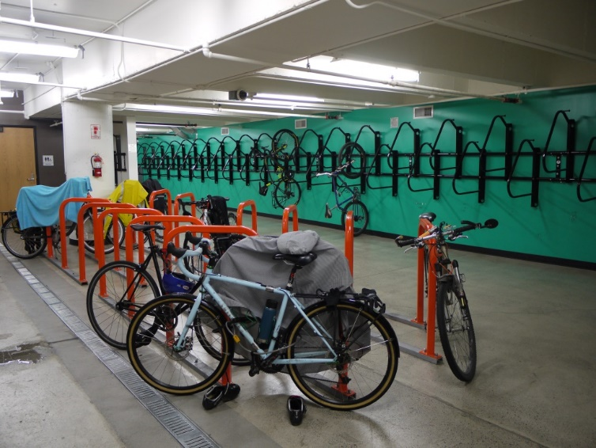

**Willamette Wellness Fitness Center**

Located through the 2WTC Plaza elevator lobby, the Willamette Wellness Fitness Center offers:

**State-of-the-Art Equipment**:

* Interactive fitness equipment for virtual live or on-demand classes.
* Treadmills, ellipticals, bikes, Climbr, Hydro rowing machine, stair mill, Echelon Mirror, multifunction trainer, free weights, and a tire flip.

**Yoga Room**: Equipped with a TV for guided sessions.

**Saunas**: Relax and unwind in our well-maintained saunas.

**Day-Use Lockers**: Secure your belongings with digital locks.

**Private Shower Rooms and Restrooms**: Clean, private facilities to freshen up after your workout.

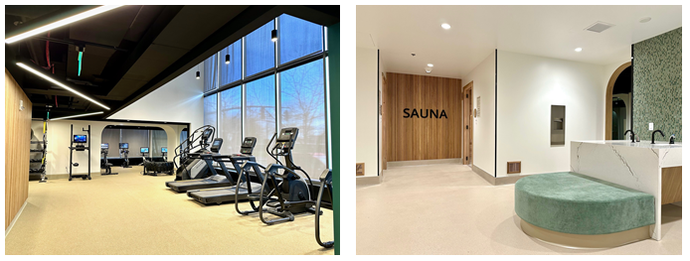

## Fit Factory

Accessible through the 2WTCP2 parking garage, the Fit Factory offers:

**Comprehensive Fitness Equipment**: Treadmills, elliptical machines, a rower, stair mill, bikes, and a variety of weight training equipment.

**Locker Room Facilities**: Separate men’s and women’s locker rooms equipped with showers and restrooms.

**Day-Use Lockers**: Available for your convenience (please bring your own lock).

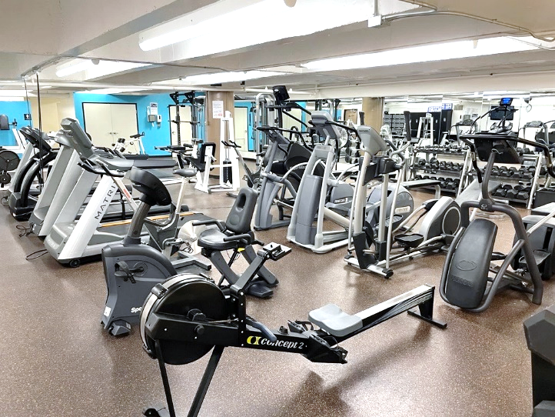

**Bike Pavilion**

Located at the 2WTC Plaza corner of Salmon and Naito, the Bike Pavilion includes:

* Bicycle storage racks
* Day use lockers with digital locks
* Changing rooms
* Repair station
* Water fill station

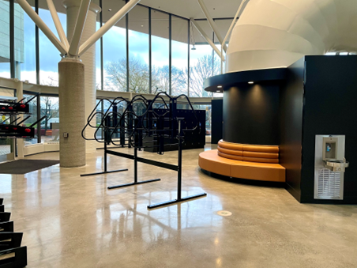

**14th Floor Tenant Lounge**

Open during business hours, the lounge is available to all tenants and their guests. Relax and enjoy the stunning views or engage in a friendly game of ping-pong.

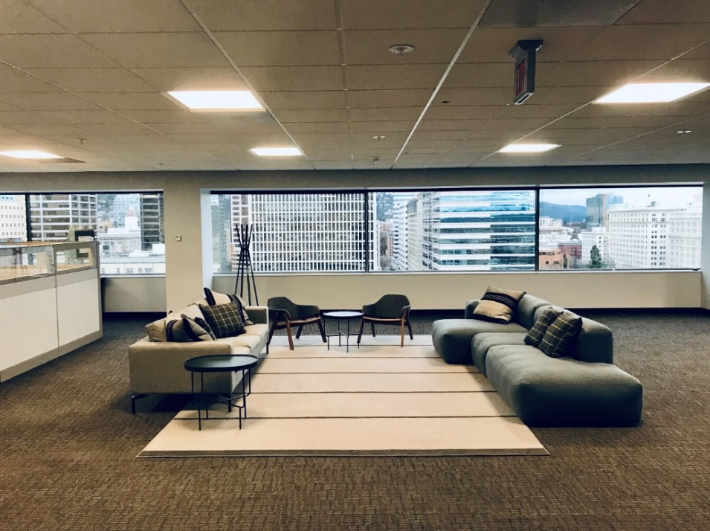

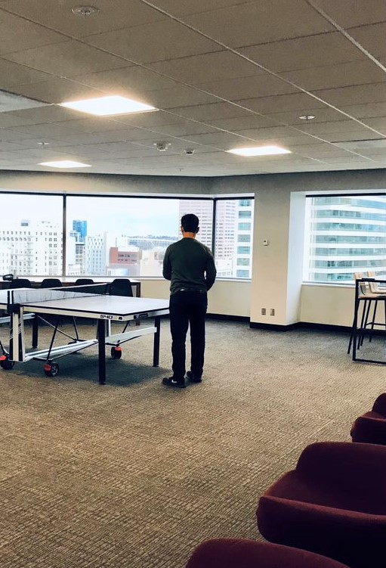

## GO Box: Located in the One World Trade lobby

World Trade Center has partnered with GO Box to facilitate the recycling of food containers (clamshells) for building occupants who frequent local food carts and restaurants. GO Box provides clamshells to participating businesses at no cost. These containers are then collected at designated sites and recycled back to the businesses. A mobile app is used to manage the receipt of new clamshells. To support this program, we have placed a collection receptacle outside the main lobby of One World Trade Center. For more information, please visit the GO Box website.

## Solar and Lunar Conference Rooms

The One World Trade Center Conference Rooms are available to tenants of One World Trade Center for a total of 16 hours per month. Reservations are made through the Angus work order system on a first-come, first-served basis. Here are some key details about the room:

* Maximum capacity: 44 occupants
* Features (2) 80” big screen TVs
* Adjustable presenter’s table
* Wireless internet access
* In-room sound system
* Touch screen control unit with step-by-step instructions for managing presentations on the big screen TVs, wireless access, and sound system for conference calls.

For additional inquiries, please contact the Property Management Office at (503) 464-7527.

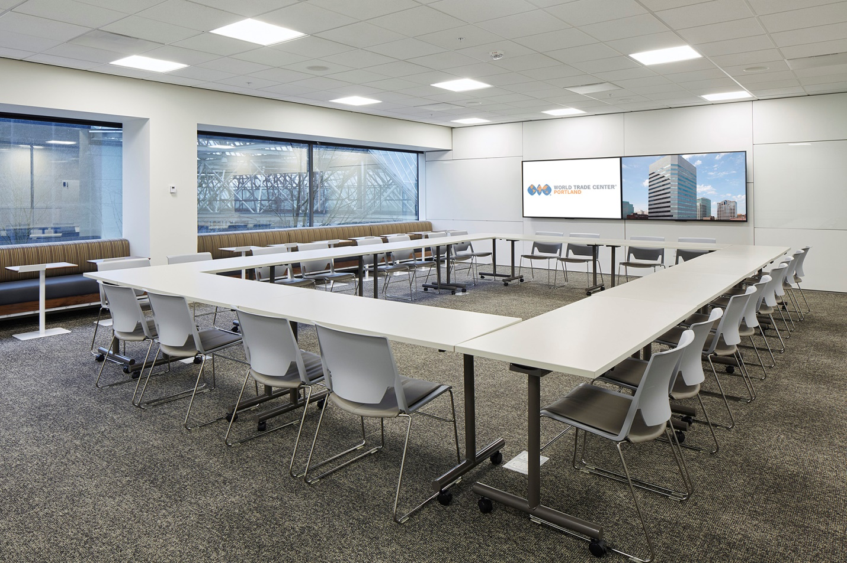

## Building ID Badges

This guideline explains photo requirements to ensure you have the a photo that accurately reflects your appearance. This helps our security team effectively restrict location access to only authorized individuals to ensure the safety of our tenants, visitors and members of the public.

**Photo or Digital Image:** Only unaltered digital photos are acceptable. Editing or filter applications will be rejected. Photos should be recently taken within the last 60 days.

**Background**: Taken indoors and in front of a plain solid white or off-white background wall. Avoid using a distracting background, like brick walls, doors, or door frames. Here are examples of acceptable background color:



**Shadow Free**: The photo must be well lit and clear.

**Full-face**: The photo should have a full-face view directly facing the camera from the shoulders to above the head with a neutral expression and both eyes open.

**Color photo**: The photo should be in color; black and white or chrome cannot be accepted.

**Not allowed:** No hats, face or head covering (other than religious), so that the hairline is not obscured. No sunglasses, face paint, bandages, stickers or contacts which change the appearance of your eyes.

**Review your photo:** Double-check to make sure it meets all the requirements above before emailing it to Corporate Security. The photo may be rejected if it does not accurately represent you and meet all of the aforementioned requirements. Here are examples of photos:

**Email your photo**

Along with a request for an ID badge, please include your name, photo and business name to [corporate.security@pgn.com](mailto:corporate.security@pgn.com).

*\*Badge photos cannot be more than five years old and should resemble the badge holder’s current appearance. If the photo is more than five years old, or the badge holder’s appearance has changed significantly, a new picture should be taken and a new badge issued.*

**FAQ’s**

**When should I submit an updated picture?**

To ensure the highest level of security within the complex, we require that the photo on your ID badge be updated every five (5) years.

**How do I submit an updated picture?**

First, ensure that your picture adheres to the badge photo guidelines. Then, simply email the photo to Corporate.Security@pgn.com.

**How do I receive my new badge and what are the next steps?**

Corporate Security will create your new badge and notify you via email once it is ready for pickup. Please note that your new badge will remain inactive until you contact Security upon receipt to activate it.

**Do I need to visit the WTC to take my picture?**

No, we have provided guidelines to assist you in taking your picture conveniently from your home or office. Once you have captured your photo, you can easily send it to us via email; there is no need to visit the WTC for this task.

**Do I require a special camera for this process?**

No, you can utilize the camera on your phone to capture your badge photo. If you do not possess a camera phone, you may ask a friend or family member who does for assistance.

.

**Tenant/ Guest/ Contractor Access**

* Lost or Stolen Access Badges: Please promptly notify security via email if an access badge is lost or stolen, or if an employee leaves and their access badge needs to be deactivated. To enhance security measures, employees locked out of the building must contact someone from their office for access, unless the company has provided an access list to the security desk, in which case a temporary badge will be issued.

**After-Hours Visitors**

* **Pre-Arranged Access:** Tenants can pre-arrange access for guests by submitting a work order in the Angus work order system prior to their arrival. Please provide the visitor's name, approximate arrival time, and your direct dial telephone number if you wish to be notified by our lobby security officer upon their arrival, enabling you to escort them to your floor.

**Authorization for Property Removal**

* **Prior Notification:** Individuals intending to remove property from the building must contact the Management Office beforehand. Please submit written notification including the removal date, involved parties (such as moving companies or individuals), and place an Angus work order in advance of the scheduled removal. Third-party companies may be required to provide evidence of insurance.

**Contractor Access**

* **Telephone and Electrical Rooms:** Access to telephone and electrical rooms, integral components of the building's mechanical system, is restricted to building personnel unless prior approval has been obtained from the Management Office through the Angus work order system.
* **Pre-Approval for Contractors:** All contractors working within the building must be pre-approved by the Management Office. Submission of a certificate of insurance is required before work can commence. Please contact the Management Office via the Angus work order system for approval.
* **Check-In Process:** Prior to starting work, all telecommunications, electrical contractors, service, and repair personnel must report to the Three World Trade Center security desk, present identification, acknowledge understanding of the building contractor rules, and receive a contractor access badge

## Building Security Services

## 

Allied Security Services provides licensed officers 24/7, including Saturdays, Sundays, and holidays, ensuring continuous protection and access control for the property. In addition to maintaining a visible presence in the lobby, officers conduct routine inspections throughout the building and offer escort services for tenants to their vehicles in the World Trade Center Garage.

**Emergency Contact Information:**

* **Emergency Services**: 9-1-1
* **Management Office**: (503) 464-7527 or (503) 464-7207
* **Building Security Emergency**: (503) 464-2888
* **Building Security Non-Emergency**: (503) 464-7183
* **Police Department Non-Emergency**: (503) 823-3333

In the event of a medical emergency requiring a 9-1-1 call, please inform the World Trade Center Security desk of your name, contact number, and precise location. This ensures that Building Security can promptly guide paramedics to your exact whereabouts.

If you hear the audible alarm within the building, refrain from contacting the Management Office or Building Security unless you have specific information to report. Once the alarm is activated, Security is automatically alerted and will investigate the cause. Please keep telephone lines clear to enable Building Security and the Property Management Office to address the situation swiftly and efficiently.

**Turnstiles**

All employees and visitors are required to possess an access badge to pass through the turnstiles. Access is seamlessly integrated into Tenant badges automatically. However, guests must be checked-in using our Angus visitor request system. This can be conveniently completed in advance by the Tenant via the Angus visitor request system, or alternatively, guests can undergo check-in on-site with security upon their arrival.

For inquiries regarding turnstile access or assistance with the check-in process, please contact Erin McConkey at [erin.mcconkey@pgn.com](mailto:erin.mcconkey@pgn.com) or (503) 464-7527.

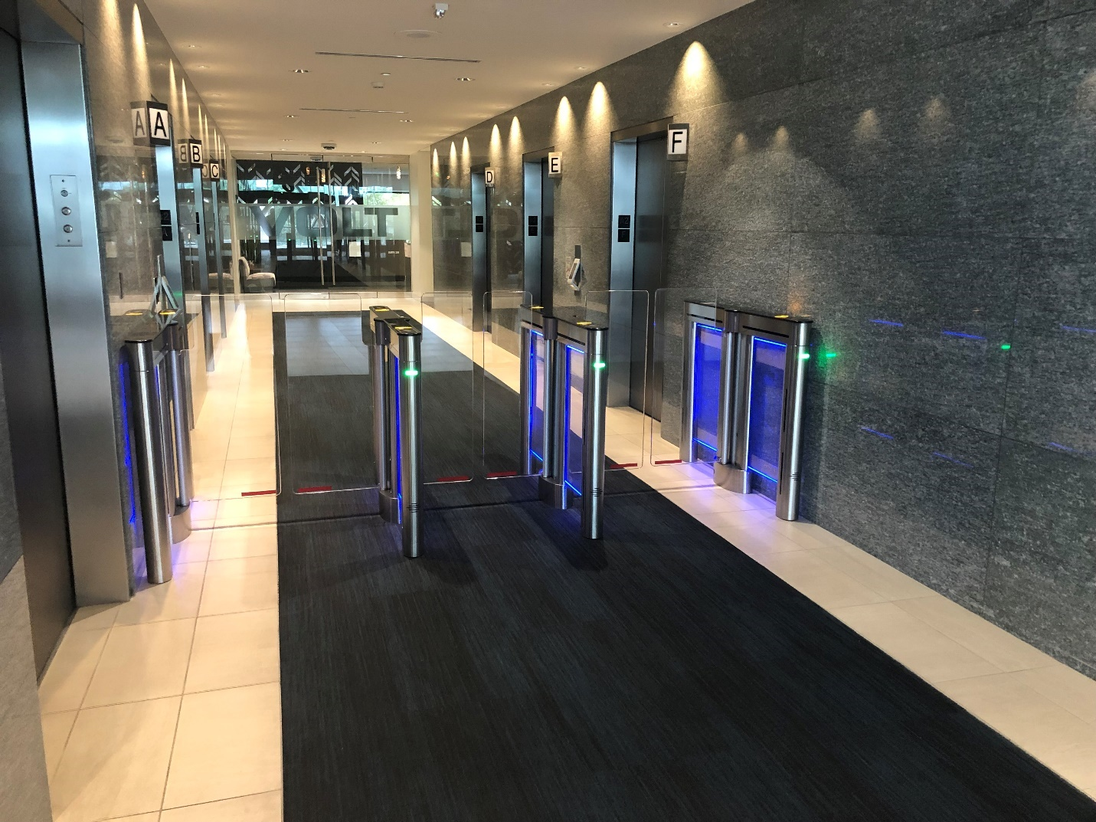

**Solicitation Policy**

Solicitations are strictly prohibited within the building premises. If approached by a solicitor in your suite, we recommend the following steps to prevent solicitors from disturbing other occupants:

1. Politely request a business card from the solicitor.
2. Ask the solicitor to wait briefly.
3. Immediately contact the security lobby desk at (503) 464-8196.
4. Provide your location and a description of the solicitor.

Upon receiving your call, our security team or a representative from the Property Management Office will promptly respond to escort the solicitor from the building.

**Theft Reporting**

Prompt reporting of any suspected theft, regardless of its scale, is essential. If you suspect theft, please take the following actions without delay:

1. Contact the Management Office at (503) 464-7527.
2. Report the incident to the non-emergency number at (503) 823-3333 or utilize the online reporting form available at <https://www.portlandoregon.gov/police/cor/>.
3. Notify your insurance carrier.

Your cooperation in promptly reporting any suspected theft ensures a swift and effective response to maintain the security and well-being of all occupants**.**

## Rent Payments and Additional Services

Rent payments are due on or before the first of each month, unless otherwise specified in your lease agreement.

For rent payments made by U.S. Mail, please ensure checks are made payable to World Trade Center Properties and sent to:

World Trade Center Properties  
PO Box 3340  
Portland, OR 97208-3340

In addition to traditional payment methods, tenants have the convenience of making payments via ACH. For further details on setting up ACH payments, please contact the property management office at (503) 464-7207.

Invoices for any additional services and after-hours HVAC usage are generated monthly by the Management Office. Please note that payments for these services are due within thirty (30) days from the date of receipt of the invoice for additional services.

Should you have any questions or require assistance regarding rent payments or additional services, please do not hesitate to reach out to our management team.

## Holiday Operations at World Trade Center Portland

During observed holidays, World Trade Center Portland operates with a reduced staff and offers limited services, as outlined below:

* **Scheduled and Pre-Arranged HVAC Services**: Available at an overtime rate for tenants with pre-scheduled needs.
* **24-Hour Building Access**: Access is controlled via access cards for tenant convenience.
* **Parking Garage Access**: Managed by Parking NW, the garage operator, ensuring seamless access for tenants.
* **Emergency Management Office Services**: Accessible by contacting the World Trade Center Security Desk at (503) 464-2888. For urgent situations, please dial 9-1-1.
* **Janitorial Service Requests**: Janitorial services can be arranged for an additional fee through the Angus work order system, provided requests are made at least 72 hours in advance

**Observed Holidays:**

* New Year's Day
* Dr. Martin Luther King Jr. Day
* Memorial Day
* Independence Day
* Labor Day
* Thanksgiving Day
* Christmas Day

**Loading Dock and Freight Elevator Access**

To ensure smooth delivery processes, all furniture and large items must be transported via the freight elevator and coordinated with the Management Office via the reservation module in the Angus work order system at least 72 hours in advance. Please note that due to limited space, loading/unloading activities exceeding 15 minutes require prior coordination.

**Office Move Timings:**

Office moves are permissible between the hours of 5:30 p.m. and 7:30 a.m. from Monday to Friday, after 12:00 p.m. on Saturday, and anytime on Sunday. Moving contractors must furnish evidence of insurance in advance, which should be provided at the time of reservation request.

**Freight Elevator Specifications:**

The freight elevator dimensions are 9’5”H x 5’4”D x 7’5”W, with a weight limit of 4000 lbs. The door opening measures 4’5”W x 7’0”H.

**Loading Dock Procedures:**

All deliveries should be directed through the loading dock situated on the north side of the building on SW Taylor Street. To expedite the process, vendors should be informed well in advance about loading dock procedures.

**Loading Dock Location:**

The loading dock is situated on the 1WTC P1 level, accessible via a ramp between First and Second on SW Taylor Street. Please note that while the entrance height is 12’ 6”, caution should be exercised by long vehicles to ensure clearance due to the ramp slope.

**Guidelines for Efficient Offloading:**

* Vehicles taller than 12’ 6” or unable to span the slope change must offload from street level.
* Trucks exceeding 30’ in length are advised against entering the loading dock; a loading zone is available on 2nd Avenue between SW Taylor and Salmon Streets.
* Moving over brick pavers on the plaza level and tile between the freight elevator and carpeted areas necessitates the use of plywood or Masonite for protection.
* Pneumatic tires are recommended to minimize impact on surfaces.
* In adherence to our LEED status, all packing materials must be recycled or removed by the moving company. A self-serve recycling center is located on P1 at One World Trade Center.

**General Office Security Recommendations**

1. Maintain Reception Area Vigilance: Never leave your reception area unattended when your suite entry door is unlocked to prevent unauthorized access.
2. Report Suspicious Activity: Promptly report all suspicious persons to the Management Office and/or Building Security. If you perceive any threat, call 9-1-1 immediately.
3. Escort Policy for Deliveries: Do not allow delivery personnel to roam through your offices unescorted. Always provide an escort to ensure security.
4. Secure Valuables: Safeguard valuables such as cash, wallets, purses, and electronic devices in a secure location. Avoid leaving purses under desks or in unlocked drawers.
5. Visitor Logbook Compliance: Enforce strict compliance with the use of a visitor logbook to record entries and exits during non-business hours.
6. Assist Strangers with Caution: Refrain from sending strangers to unoccupied offices to use telephones. Offer to assist by dialing the number or escort them to a phone, remaining with them until they complete their call.
7. Vet Contractors and Vendors: Do not grant unrestricted access to contractors or vendors. Verify their identity with the Management Office and/or Building Security before allowing entry.
8. Exercise Alertness: Question strangers and request business cards or ID badges. Escort unfamiliar individuals to their destination within the office. If uncertain, contact the Management Office and/or Building Security for assistance.
9. Secure Premises at End of Day: Lock all doors when securing your premises at the end of the business day. Consider locking corridor doors even during late work hours.
10. Heightened Awareness During Vulnerable Times: Offices are susceptible to theft during lunch breaks and before closing. Remain vigilant during these periods when desks are frequently unattended.
11. Equipment Documentation: Document serial numbers of all business equipment to aid law enforcement in recovering stolen items.
12. Security Measures upon Employee Termination: Consider rekeying entrance locks or resetting access codes when an employee is terminated to prevent unauthorized access.
13. Key Identification: Keys should not have identifying tags to prevent unauthorized access if lost.
14. Supervise Corridor Deliveries: Do not leave items unattended in corridors during delivery.

**Heating and Air Conditioning System Operations**

The standard operating hours for the heating and air conditioning system are from 5:30 a.m. to 5:30 p.m., Monday through Friday, and from 9:00 a.m. to 12:00 p.m. on Saturdays.

For after-hours heating or cooling requirements, please submit an Angus work order request at least 24 hours in advance. The rates for after-hours requests are as follows:

* $35.00 per hour for half floor usage
* $70.00 per hour for full floor utilization

Please note that depending on location needs, you may be billed for a full floor.

**Temperature Adjustment Requests**

Should the temperature in your office require adjustment, please submit an Angus work order request. Your request will be promptly addressed and dispatched at no additional charge.

## Cleaning Services

Cleaning services are provided five nights a week, from Sunday through Thursday. Our dedicated team ensures that carpets are vacuumed, surfaces are dusted, and trash is promptly emptied.

**Attention to Detail**

We kindly request that non-trash items are not left on or near wastebaskets to avoid any misunderstandings. Should you have specific cleaning needs, such as carpet shampooing, please contact the Management Office via the Angus work order system. Specialized cleaning services can be arranged at the tenant's expense.

**Commitment to Green Cleaning Practices**

World Trade Center Portland is committed to environmentally friendly cleaning practices endorsed by the United States Green Building Council (USGBC). Our approach includes the use of microfiber cloths, chemical dilution control, and state-of-the-art equipment to minimize environmental impact.

**Timely Resolution of Cleaning Issues**

For any minor cleaning issues during working hours, please submit an Angus work order request for prompt attention.

**Stringent Quality Control Measures**

Building Operations, in collaboration with the janitorial company's Account Manager, conducts regular inspections to uphold the highest maintenance and sanitation standards. We value your feedback; please do not hesitate to reach out to the Management Office with any questions or comments regarding our cleaning services.

**LEED Gold Certified Property**

World Trade Center Portland holds LEED Gold certification, underscoring our commitment to sustainability. We encourage waste reduction, recycling, and composting initiatives. Further details on our comprehensive recycling program can be found on our website or on page 22 of this document.

## Lost and Found Procedures

## Should you discover any lost or missing items, please promptly report them to the security desk situated in the lobby of Three World Trade Center. Our dedicated team is committed to assisting you in retrieving your belongings.

## Found Items Protocol

## Items found on the premises are diligently cataloged and securely stored for a period of 30 days to facilitate their safe return to their rightful owners.

## Contact Information

## For inquiries regarding lost or found items, please reach out to the Three World Trade Center security desk at (503) 464-8196. Our staff is readily available to aid and support in reuniting you with your belongings

## Mailroom and Package Handling

The mailroom, conveniently situated on P1 of One World Trade Center, serves as the central hub for all incoming packages, including deliveries from Amazon. Tenants can easily access the mail window to retrieve their business mail.

**Mail Delivery Process**

Incoming USPS mail is sorted and placed in keyed mailboxes by the postal service for secure retrieval. Additionally, designated drop boxes for outgoing USPS mail, UPS Express, and FedEx shipments are conveniently located in the elevator lobby of P1 for tenant convenience.

**Special Instructions for Food Deliveries**

For food deliveries, tenants are required to meet delivery personnel in the lobby of One World Trade Center and accompany them to their respective floors.

**Contact Information**

Should you have any inquiries regarding our mailroom policies or package handling procedures, please don't hesitate to contact the Management Office at (503) 464-7207. We are here to assist you with any questions or concerns you may have.

## Efficient Maintenance Requests

## Maintenance requests for temperature adjustments, lighting issues, access card concerns, and additional janitorial services can be conveniently submitted via the Angus work order system. This intuitive application enables both tenants and Management staff to effectively track all service and maintenance requests for timely resolution.

## Access to the Angus Work Order System

## As a new tenant at World Trade Center Portland, you will be provided with access to the Angus work order system. You'll have the flexibility to designate the individuals within your office who will have access to the system. Simply complete a form to specify your preferences.

## Accessing the Angus Work Order System

## You can access the Angus work order system via the link provided on our World Trade Center website at [www.wtcpdx.com](http://www.wtcpdx.com/) under the "Tenants & Leasing" section. The system allows seamless submission of maintenance requests and reservations for your convenience.

## Assistance and Support

## Should you require any assistance or guidance regarding the Angus work order system, please don't hesitate to reach out to the Management Office at (503) 464-7527. Our team is dedicated to providing prompt and reliable assistance to ensure a smooth experience for all tenants.

## World Trade Center Parking Facilities

Our comprehensive parking amenities feature a two-level parking garage with a capacity of 480 stalls, conveniently situated beneath the three-building complex. Accessible via SW Taylor Street near Naito Parkway, the parking garage provides secure and convenient parking solutions for tenants of World Trade Center Portland.

**Electric Vehicle Charging Stations**

Within the garage, tenants have access to 10 electric vehicle parking spaces on level P1, equipped with charging capabilities. These spaces cater to the growing demand for sustainable transportation options, reflecting our commitment to environmental stewardship.

**Parking Options**

Monthly parking is exclusively available to tenants of World Trade Center Portland, with allocations based on respective lease agreements. Day parking is provided on a first-come, first-served basis, offering flexibility for visitors and tenants alike.

**Management and Contact Information**

Parking NW manages our parking garage operations. For inquiries or assistance, please contact Parking NW at (503) 800-1003 or via email at info@parkingnw.com.

**Electric Avenue**

Electric Avenue, a pioneering initiative originally established at Portland State University (PSU) in 2011, relocated to World Trade Center Portland in 2016. In response to Oregon's increasing adoption of electric vehicles, Electric Avenue offers essential charging infrastructure to support sustainable transportation practices.

**Location and Usage**

Situated on SW Salmon Street adjacent to the entrance of World Trade Center Portland, Electric Avenue provides charging services for electric vehicles. Please note that a fee for charging, along with applicable City of Portland parking fees, is required. To comply with city regulations, parking spaces designated for charging must be utilized accordingly, as vehicles found not charging may incur fines.

## Sustainability Initiatives at World Trade Center Portland

As a testament to our commitment to sustainability, World Trade Center Portland proudly holds LEED Gold certification. In line with our environmental goals, we have implemented a comprehensive building-wide recycling program, aiming for an impressive 80% diversion rate.

**Recycling Program Details**

Our recycling program encompasses co-mingled recycling for paper, clean plastic bottles, and tins, with the aim of minimizing waste and promoting responsible resource management. Additionally, composting is mandatory for all tenants at World Trade Center Portland, reflecting our dedication to reducing organic waste and fostering eco-friendly practices.

**Wastebasket Liners**

To facilitate proper waste sorting, our wastebasket liners are color-coded as follows:

* Black liners: designated for trash
* Clear liners: reserved for recycling
* Green liners: allocated for compostable materials

**Janitorial Services**

Our dedicated janitorial team conducts nightly pickups (Sunday through Thursday) of various recyclable materials, including paper, cardboard (to be broken down and placed by the paper recycling bin), glass, and co-mingle recycling items such as tin, foil, and plastic containers. Additionally, Friday afternoon pickups focus on composting, encompassing all vegetation and plant matter.

**Self-Serve Recycling Options**

For convenient disposal of e-waste and metal items, self-serve recycling stations are available on the P1 level of 1WTC. These stations facilitate responsible disposal of electronics, cell phones, computers, monitors, printers, and other metal materials, contributing to our efforts in waste reduction and recycling.

**Important Reminder**

To ensure compliance with fire code regulations and maintain safe building access, please refrain from storing oversized rubbish in the service elevator, corridors, or elevator lobbies, even temporarily. For additional resources and information on recycling practices, you can visit Metro's "Recycle at Work" website at [www.recycleatwork.com](http://www.recycleatwork.com/).

## Tenant Storage Options

## At World Trade Center Portland, we offer convenient storage solutions tailored to your needs, available on both long-term and month-to-month rental terms. Whether you require additional space for archival documents, equipment, or inventory, we have flexible storage arrangements to accommodate your requirements.

## Inquire About Storage Availability

## For information regarding storage space availability and rental options, please don't hesitate to reach out to the Management Office. You can contact us at (503) 464-7207 or via email at [sumandhi.fox@pgn.com](mailto:sumandhi.fox@pgn.com). Our dedicated team is ready to assist you in finding the ideal storage solution to meet your needs.

## Telecommunication Telephone Closets

Security is always a concern. Telephone security is one of the areas we focus on at the complex. At World Trade Center Portland, we try to balance convenience of change with protection of your phone and data lines as they run from your space into and out of the building. While we cannot guarantee the security of these lines, we do want to take reasonable precautions. Please notify the World Trade Center Management Office via an Angus work order to schedule a vendor appointment each time access to floor telephone closets is required. In turn, Security will be notified to expect a vendor visit. **Contractors showing up unannounced will not be allowed access to telecom closets.** Contractors for vendor companies must provide a date and estimated time 48 hours prior to arrival, check in at the Three World Trade Center Security desk, produce a company ID and fill out a form each time they check out keys for the building. Contractors will be escorted by a Building Engineer to the telecom closet. If workmanship is not up to building standards, future access by that contractor may not be allowed.

There are a large number of vendors in the marketplace today of varying expertise. As you can imagine, there are thousands of wires serving a complex this size. An error in a connection can have repercussions over multiple tenants. Therefore, quality control is a top priority. As a result, the only vendors authorized to do work in the building demarcation are **Century Link, GG Telecommunications, Comcast and Time Warner/Integra**. Work may be contracted directly with these vendors.

Access to the telecom rooms on all floors will be handled in the same way except for full floor tenants. For those in that category, we can assist with access to your equipment by your vendor with proper identification.

## Building and Parking Rules and Regulations

1. Except as specifically provided in the Lease to which these Rules and Regulations are attached, no sign, placard, picture, advertisement, name or notice shall be installed or displayed on any part of the outside or inside of the Building, or in any Common Area, without the prior written consent of Landlord. Landlord shall have the right to remove, at Tenant’s expense and without notice, any sign installed or displayed in violation of this rule. All approved signs or lettering on doors and walls shall be printed, painted, affixed or inscribed in accordance with any terms or conditions specified by Landlord at the expense of Tenant by a person approved by Landlord.
2. If Landlord objects in writing to any curtains, blinds, shades, screens or hanging plants or other similar objects attached to or used in connection with any window or door of the Premises, or placed on any windowsill, which is visible from the exterior of the Premises, Tenant shall immediately discontinue such use. Tenant shall not place anything against or near glass partitions or doors or windows that may appear unsightly in Landlord’s judgment from outside the Premises. Landlord shall have the right to remove, at Tenant’s expense and without notice, any object installed or displayed in violation of this rule. No items or decorations are to be hung from lighting fixtures, ceiling systems, fire alarm devices, fire sprinkler piping or fire sprinkler device.
3. Tenant shall not obstruct any sidewalks, halls, passages, fire corridors, exits, entrances, elevators or stairways of the Building or in any Common Area. The halls, passages, exits, entrances, elevators and stairways are not open to the general public, but are open, subject to reasonable regulations, to Tenant’s business invitees and other tenants. Landlord shall in all cases retain the right to control and prevent access thereto of all persons whose presence in the judgment of Landlord would be prejudicial to the safety, character, reputation and/or interest of the Building and its tenants; provided that nothing herein contained shall be construed to prevent such access to personnel with whom any tenant normally deals in the ordinary course of its business, unless such persons are engaged in illegal or unlawful activities or in Landlord’s judgment pose a safety or security risk. No tenant and no employee or invitee of any tenant shall go upon the roof(s) of the Building.
4. Landlord will furnish Tenant, free of charge, with two keys to each door lock in the Premises. Landlord may make a reasonable charge for any additional keys. Tenant shall not make or have made additional keys, and Tenant shall not alter any lock or install a new additional lock or bolt on any door of its Premises. Tenant, upon the termination of its tenancy, shall promptly deliver to Landlord the keys of all doors which have been furnished to Tenant, and in the event of loss of any keys so furnished, shall promptly pay landlord.
5. If Tenant requires cellular, telephonic, computer, burglar alarm or similar services, Tenant shall first obtain, and comply with, Landlord’s instructions and restrictions in their installation, operation and/or maintenance. Such services shall be at Tenant’s risk and expense and Landlord will not be responsible for loss of, or damage to, any such equipment or have any liability associated with such services.
6. No equipment, materials, furniture, packages, supplies, merchandise or other property will be received in the Building or carried in the elevators except between such hours and in such elevators (the freight elevator unless otherwise directed by Landlord) as may be designated in each instance by Landlord. Tenant’s move out, initial move in and subsequent deliveries of bulky items, such as furniture, safes and similar items shall be prescheduled with Landlord and, unless otherwise agreed in writing by Landlord, be made at times other than during Business Hours on Monday through Friday. Deliveries during normal office hours shall be limited to normal office supplies and other small items.
7. No deliveries shall be made which impede or interfere with the use of the elevators or any Common Area, by other tenants, or the operation of the Building in general. Freight elevators to be used exclusively for moving freight and other items and are not to be used in lieu of the standard elevators.
8. Tenant shall not place a load upon any floor of the Premises that exceeds the load per square foot that such floor was designed to carry and which is allowed by applicable law. Landlord shall have the right to prescribe the weight, size and position of all equipment, materials, furniture or other property brought into the Building. Heavy objects shall, if considered necessary by Landlord, stand on such platforms as determined by Landlord to be necessary to properly distribute the weight, which platforms shall be provided at Tenant’s expense. Business machines and mechanical equipment belonging to Tenant which cause noise vibration that may be transmitted to the structure of the Building or to any space therein shall be placed and maintained by Tenant, at Tenant’s expense, on vibration eliminators or other devices sufficient to eliminate noise or vibration. The persons engaged to move such equipment in or out of the Building must be acceptable to Landlord. Landlord will not be responsible for loss of, or damage to, any such equipment or other property from any cause, and all damage done to the Building by maintaining or moving such equipment or other property shall be repaired at the expense of Tenant.
9. Tenant shall not use or keep in the Premises any kerosene, gasoline or flammable or combustible fluid or material other than those limited quantities necessary for the operation or maintenance of office equipment. Tenant shall not use or permit to be used in the Premises any foul or noxious gas or substance, or permit or allow the Premises to be occupied or used in a manner offensive or objectionable to Landlord or other occupants of the Building by reason of noise, odors or vibrations.
10. No open flame (e.g., candles or other source) shall be generated or used in the Building or Common Areas.
11. Tenant shall not use any method of heating or air conditioning other than that supplied by Landlord.
12. Tenant shall not waste electricity, water or air conditioning and agrees to cooperate fully with Landlord to assure the most effective operation of the Building’s heating and air conditioning and to comply with any governmental energy-saving rules, laws or regulations of which Tenant has actual notice, and shall refrain from attempting to adjust controls. Tenant shall keep corridor doors closed.
13. Landlord reserves the right, exercisable without notice and without liability to Tenant, to change the name and street address of the Building. Landlord shall have the right to prohibit use of the name or image of the Building, any intellectual property right of Landlord, or any other publicity by Tenant that in Landlord’s sole opinion may impair the reputation of the Building or its desirability.
14. Landlord reserves the right to exclude from the Building between the hours of 6 p.m. and 7 a.m. the following day, or such other hours as may be established from time to time by Landlord, and on Saturdays and Sundays and legal holidays, any person unless that person is known to the person or employee in charge of the Building and has a pass or is properly identified. Tenant shall be responsible for all persons for whom it requests passes and shall be liable to Landlord for all acts of such persons. Landlord shall not be liable for damages for any error with regard to the admission to or exclusion from the Building of any person. Landlord reserves the right to prevent access to the Building in case of invasion, mob, riot, public excitement, commotion or safe try or security risk by closing the doors or by other appropriate action.
15. Tenant shall entirely shut off all water faucets, coffee makers/machines, or other water apparatus, and electricity, gas or air outlets before Tenant and its employees leave the Premises each day. Tenant shall be responsible for any damage or injuries sustained by other tenants or occupants of the Building or by Landlord for noncompliance with this rule.
16. The toilet rooms, toilets, urinals, wash bowls and other apparatus shall not be used for any purpose other than that for which they were constructed and no foreign substance of any kind whatsoever shall be thrown therein. Tenant shall at all times keep the Premises at a temperature sufficiently high to prevent freezing of water pipes and fixtures. The expense of any breakage, stoppage or damage resulting from the violation of this rule shall be borne by the tenant who, or whose employees or invitees, shall have caused it.
17. Tenant shall not sell, or permit the sale at retail of newspapers, magazines, periodicals, theater tickets or any other goods or merchandise to the general public in or on the Premises or in any Common Area. Tenant shall not make any room-to-room solicitation of business from other tenants in the Building or in any Common Area. Tenant shall not use the Premises for any business or activity other than that specifically provided for in Tenant’s Lease. Canvassing, soliciting and distribution of handbills or any other written material and peddling in the Building or in any Common Area are prohibited, and Tenant shall cooperate to prevent such activities.
18. Tenant shall not install any radio, computer or television antenna, loudspeaker or other devices on the roof(s) or exterior walls of the Building without Landlord’s prior written consent. Tenant shall not create any electrical or magnetic interference or interfere with radio, computer or television broadcasting or reception from or in the Building or elsewhere.
19. Tenant shall not (i) conduct or permit any fire, bankruptcy or auction sale (whether real or fictitious) unless and to the extent directed by order of a court of competent jurisdiction and upon not less than three (3) days prior written notice to Landlord, or conduct or permit any legitimate or fictitious “Going Out of Business” sale nor represent or advertise that it regularly or customarily sells merchandise at “manufacturer’s”, “distributors”, or “wholesale”, “warehouse”, or similar prices other than at “off price” or at “retail” prices: (ii) use, or permit to be used, the Common Areas or sidewalks adjacent to the Premises, or any other area outside the Premises for solicitation or for the sale or display of any merchandise or service or for any other business, occupation, or undertaking, or for outdoor public meetings, circus or other entertainment (except for promotional activities in cooperation with Landlord); (iii) use or permit to be used any flickering lights or any sound broadcasting or amplifying device which can be heard outside of the Premises; or (iv) use or permit to be used any portion of the Premises for any unlawful purpose or use or permit the use of any portion of the Premises as regular living quarters, sleeping apartments or lodging rooms or for the conduct of any manufacturing business.
20. Except in connection with hanging pictures and other customary office decorations, Tenant shall not mark, drive nails, screw or drill into the partitions, woodwork or plaster or in any way deface the Premises or any part thereof, except in accordance with the provisions of the Lease pertaining to alterations. Landlord reserves the right to direct licensed electricians as to where and how communication, cabling, and data wires and interfaces are to be located and introduced to the Premises. Tenant shall not cut or bore holes for wires. Tenant shall not affix any floor covering to the floor of the Premises in any manner except as approved by Landlord. Tenant shall promptly repair any damage resulting from noncompliance with this rule at Tenant’s expense.
21. Tenant shall not install, maintain or operate upon the Premises any vending machines, concessions, or video games without the prior written consent of Landlord.
22. Landlord reserves the right to exclude or expel from the Building any person who, in Landlord’s judgment, is a safety or security risk, intoxicated or under the influence of liquor or drugs, or who is in violation of any of the Rules and Regulations of the Building.
23. No animals (including birds), except those assisting physically impaired persons, shall be brought in the Building or kept in or about the Premises or Common Areas.
24. Tenant shall store all its trash, composting and recycling within its Premises or in other facilities provided by Landlord. Tenant shall not place in any trash box or receptacle any material that cannot be disposed of in the ordinary and customary manner of trash or recycling. All garbage, composting, recycling and refuse disposal shall be made in accordance with directions issued from time to time by Landlord.
25. The Premises shall not be used for the storage of merchandise held for sale to the general public, or for lodging or for manufacturing of any kind, nor shall the Premises be used for any improper, immoral or objectionable purpose. No cooking shall be done or permitted on the Premises without Landlord’s consent, except that use by Tenant of Underwriters’ Laboratory approved equipment for brewing coffee, tea, hot chocolate and similar beverages or use of microwave ovens for employee use shall be permitted, provided that such equipment and use is in accordance with all Legal Requirements. Such equipment shall be at Tenant’s risk and expense and Landlord will not be responsible for loss of or damage to, any such equipment or have any liability associated with such equipment. All coffee makers, water service or other equipment requiring plumbing shall use copper or braided steel tubing, no plastic.
26. Tenant shall not use in any space or in the public halls of the Building any hand truck except those equipped with rubber tires and side guards or such other material-handling equipment as Landlord may approve. Tenant shall not bring any other vehicles of any kind into the Building. Care should be given when loading and unloading to not damage the elevator cabs, trim and thresholds, nor adjacent common areas.
27. Tenant shall promptly comply with all safety, security, fire protection and evacuation directives, procedures and regulations established by Landlord or any governmental agency.
28. Tenant assumes any and all responsibility for protecting its Premises from theft, robbery and pilferage, which includes keeping doors locked and other means of entry to the Premises closed. Landlord will not be responsible for loss of or damage to, any property of Tenant.
29. Tenant’s requirements will be attended to only upon appropriate application to the Building management office by an authorized individual. Employees of Landlord shall not perform any work or do anything outside of their regular duties unless under special instructions from Landlord.
30. Tenant shall keep Landlord advised of all management personnel changes and emergency phone numbers.
31. Landlord reserves the right, from time to time without unreasonable interference with Tenant’s use, to: (a) install, use, maintain, repair and replace pipes, wires and other equipment above the ceiling surfaces, below the floor surfaces, within the walls and/or in the essential core areas of the Building, (b) to add to, modify, or to delete from the common areas of the Building, (c) to do work in the common areas of the Building, and/or to close temporarily any of the common areas (so long as reasonable access to individual premises remains available), and (d) to do and perform such other acts and makes such other changes in, to or with respect to the common areas of the Building or the Building as Landlord may deem appropriate.
32. Loading docks are to be used for loading and unloading only and only during normal Business Hours. Loading docks may be available at other times upon prior request by Tenant. No vehicles may be parked at or blocking access to the loading dock by other vehicles. Vehicles left unattended for deliveries or pick-ups must have blinker lights on

and must be moved within fifteen (15) minutes. Note the limitations on the use of elevators set forth in Section 6 above.

1. Any cabling or wiring installed on or about the Premises (including without limitation the risers, plenum, telecommunications spaces, and the roof and exterior of the Building) during the Term shall be “fire safe” and meet or exceed the requirements of both the then current national and local electrical, fire and safety codes. In conjunction with the installation or modification of any cabling or wiring Tenant, at Tenant’s risk and expense, shall remove and properly dispose of any abandoned cabling and wires, as defined by the National Electric Safety Code, within the demised Premises (including without limitation the risers, plenum, telecommunications spaces, and the roof and exterior of the Building). Upon the expiration or termination of the Lease, Tenant, at Tenant’s risk and expense, shall promptly remove and properly dispose of all abandoned cabling and wires, as defined by the National Electric Safety Code, within and/or associated with the demised Premises (including without limitation the risers, plenum, telecommunications spaces, and the roof and exterior of the Building), unless excused in writing by Landlord.
2. The following rules and regulations are in addition to the terms and conditions of the World Trade Center Monthly Parking Agreement, the terms and conditions of which are hereby incorporated by reference herein, and shall govern use of the parking facilities that are appurtenant to the Building. Tenant shall not park or permit the parking of any vehicle in any parking areas designated by Landlord as areas for parking by visitors to the Building.
3. No overnight or extended term parking or storage of vehicles shall be permitted.
4. Tenant shall not park any vehicles in the parking areas other than automobiles and motorcycles.
5. Vehicles must be parked entirely within painted stall lines of a single parking stall.
6. All directional signs and arrows must be observed.
7. The speed limit within all parking areas shall be ten (10) miles per hour.
8. Parking is prohibited in areas not striped for parking; in aisles; where “no parking” signs are posted; on ramps; in cross-hatched areas; and in such other areas as may be designated by Landlord.
9. The parker assumes all responsibility for damage to vehicles or theft of property.
10. Washing, waxing, cleaning or servicing of any vehicle in any area is prohibited.
11. Landlord reserves the right to establish and change parking fees and to modify and/or adopt such other reasonable and nondiscriminatory rules and regulations for the parking facilities as it deems necessary for the operation of the parking facilities.
12. Landlord may refuse to permit any person who violates these rules to park in the parking facilities, and any violation of the rules shall subject the car to removal at the owner’s expense and without any liability to Landlord whatsoever.
13. Designated electric vehicle parking is for electric vehicle charging only at all times. Tenant shall observe and comply with all posted and designated electric charging parking signage.
14. Bicycles and other vehicles are not permitted inside the elevator, Building or the walkway outside the Building, except in areas designated by Landlord.
15. The use of tobacco or e-cigarette products (e.g., cigarettes, cigars, pipes, smokeless tobacco, snuff and vapes) is prohibited in the Premises or elsewhere in the Building and in all other portions of the Complex except in exterior Designated Tobacco Use Areas which shall be located and designated by Landlord from time to time by such signage as Landlord deems appropriate. All tobacco products, whether smokeless or not, must be promptly disposed of in a safe and hygienic manner. Tenant, at Tenant’s expense, shall at all times keep and maintain its Premises as a "Non-Tobacco Use" area.
16. Landlord may waive or modify any one or more of these Rules and Regulations for the benefit of Tenant or any other tenant, but no such waiver or modification by Landlord shall be construed as a waiver of such Rules and Regulations in favor of Tenant or any other tenant, nor prevent Landlord from thereafter enforcing any such Rules and Regulations against any or all Tenants of the Building.
17. These Rules and Regulations are in addition to and shall not be construed to in any way modify or amend, in whole or in part, the terms, covenants, agreements and conditions of the Lease.
18. Landlord reserves the right to modify the foregoing and/or to make such other and reasonable Rules and Regulations as, in its judgment may from time to time be needed for safety and security, for care and cleanliness of the Building and for the preservation of good order therein. Tenant agrees to abide by all such Rules and Regulations hereinabove stated and any additional rules and regulations that are adopted.
19. Tenant shall be responsible for the observance of and the prompt and continuous compliance with all of the foregoing rules by Tenant’s employees, agents, clients, customers, invitees and guests and for all costs and expenses associated with the violation thereof.

## Tenant Alterations, Construction Regulations and Renovations

Please coordinate all alterations with the Building Manager. In most cases, alterations require approval by the Management Office. Please refer to your respective lease for specific terms. Requests to make alternations should be sent in writing to:

Paul Wallman

Facilities Manager

121 SW Salmon, Suite 230

Portland, OR 97204

All construction contractors working within each tenant space including general, HVAC, electrical, plumbing or telecom contractors must check in with security prior to performing any work in the building (see “Tenant/Guest/Contractor Access”)

**Intent**

These general requirements are to communicate performance expectations and requirements of contractors performing work projects within the World Trade Center Portland complex. While these requirements may not cover all specific project requirements, or may not apply to all projects, they are intended to communicate a basic overall methodology for doing construction work, and projects, at World Trade Center Portland. Upon request to make alterations, a written response back with approval or rejection and rationale will be sent.

**Preliminary**

* All work performed shall comply with all applicable rules, regulations, and codes of the building, city, state, and federal governmental agencies having jurisdiction. The general contractor will file drawings and secure all required permits prior to beginning work, unless circumstances require earlier construction commencement, as directed by the Owner’s architect. All construction within the leased premises shall conform to the American with Disabilities Act (ADA).
* All work shall be performed during regular business hours from 7:00 am - 6:00 pm, Monday through Friday, with the exception of disruptive work. The types of disruptive activities are listed below under exceptions. All building system operations will be maintained in normal operation and will not be adversely impacted by construction work unless specifically authorized by the Management Office. The contractor shall communicate requests to the Management Office 48-hours in advance of any required interruption of any building services.

**Exceptions**

The following work is required to be performed on an overtime or off-hours basis: core drilling, impact driven fasteners, any volatile or odor creating substances, any type of concrete chipping, and any other work creating noise that will impact a neighboring tenant or the building as a whole.

At the Management Office’s sole discretion, any work creating a nuisance to neighboring tenants may be required to be completed on an off-hour basis. Any scheduling requests for these types of off-hours work must be approved and authorized by the Management Office prior to performance of any work.

* Work occurring on the roof shall be performed with full protection afforded the roofing membrane. Appropriate ballast shall be placed on the roof anywhere materials are to be placed for installation. Placement of materials shall not be allowed to overload the roof membrane, insulation, or structure below. Fall protection shall follow and be incompliance with OSHA requirements.
* All contractors must supply certificate(s) of insurance naming Portland General Electric Company, 121 Salmon Street Corporation and its officers, agents and employees as additional insured. Exact verbiage is critical. Insurance certificates and copies of permits, as required, must be provided to the Management Office prior to the commencement of any work.
* Contractor’s representative will meet with a Management Office representative(s) prior to beginning contracted work, to review the scope of construction work, construction methods, these general requirements, any additional project specific requirements, project schedule, and any potential impact to the satisfactory on-going operation of building services.
* The contractor will coordinate proper parking locations for construction personnel with the Management Office prior to starting construction, to avoid impacting tenant parking availability.

**Project Area Access**

* Access to the buildings or parking garage will be coordinated in advance with the Management Office. No installed access control or security system will be overridden or bypassed for any reason, or at any time. All construction personnel will be limited to those areas for which they have been given specific access.
* Access to all electrical closets, telecom closets, mechanical rooms, and suites must be coordinated not less than 48 hours in advance through the Management Office. Electrical, telecom, and other equipment rooms will be kept closed and locked when they are not physically occupied.
* Keys and/or access cards will be checked out each day from the Three World Trade Center security desk. Contractor will be responsible for all lost keys or access cards. Responsibility may include, but not be limited to, the cost to replace, re-key, and/or reprogram locks and access cards.
* All contractors and sub-contractors shall sign in and out each day and shall be issued contractor badges by security that must be worn at all times while in building(s).

**During Work Performance**

* Upon the start of construction, the contractor will provide high quality sticky walk-off mats for exiting at all entrances to the construction area(s) from stairwells (if used) and lobby entrances.
* Contractors shall maintain cleanliness throughout and not clutter or block hallways, exits, elevator lobby, electrical or telephone rooms. Building fire rated doors will not be propped open, removed, or their door closures disconnected. Nor will elevator doors be propped or jammed open to prevent the automatic function of its timed door actuators.

**Contractors are required to utilize only the freight elevator during performance of work**.

* Building electrical, telecom closets, stairwells, lobbies, tenant spaces, will not, at any time, or for any reason, be utilized for the storage of any construction materials or trash, as such storage constitutes a violation of prevailing fire codes.
* All material deliveries, and debris removal, must be completed before 7:00 a.m. or after 6:00 p.m. and made as expeditiously as possible so as to not have these vehicles blocking accesses to / from the building. The contractor, at contractor expense must remove all construction debris from the building. Building trash dumpsters are not to be utilized for the disposal of construction debris, as these are provided for tenant use. Contractor may arrange for delivery of a debris box for use. The Management Office will approve an appropriate location for the debris box while it is on the project. Delivery or removal of large amounts of material is to be done after normal business hours with 24-hour prior approval of the Management Office.
* The contractor is responsible for taking the following precautions / steps to protect the satisfactory on-going operation of all building systems and tenant operations:
* Covering HVAC supply and return duct openings to protect from construction dirt / dust being spread to other areas of the building or into the HVAC equipment / system. This can be accomplished by sealing off, covering with filtering media, or other approved method.
* Coordinate with Building Manager prior to construction to have fire sprinkler systems isolated, smoke detectors disabled, or alarm systems de-activated for periods as may be necessary. Contractor will protect those smoke detectors or fire sprinkler heads left installed in the area, after disabling, by covering them with plastic bags during construction. Plastic or other disabling means shall be removed at the end of each construction period. In no cases, shall fire alarm equipment remain disabled after construction crews are finished with their day’s work.
* Where electrical components or circuits are removed, contractor will ensure full compliance with OSHA required lockout / tagout procedures to prevent personal injuries or system outages. Develop the best isolation possible of the construction area to contain any dirt, dust, noise or other potential tenant impact which may be generated by demo and construction work.
* Any damage caused to any project area by the contractor, including but not limited to, parking areas, doors, freight elevators, roofing, exterior skin and carpets will be reported to the Management Office and repaired by the contractor immediately. World Trade Center Portland reserves the right to remedy any damage at the Contractors expense if the damage is not repaired in a timely manner.
* No powder-actuated guns are to be used without the specific prior authorization of the Management Office.
* No foreign substances (such as paint or grout) are to be poured down any restroom floor drains, or into other restroom fixtures.
* All firewall and floor penetrations shall be sleeved and sealed in accordance with applicable fire code, using only approved, UL listed, fire stop materials. All firestop installations must be reviewed and approved by the Management Office prior to closing the associated area of work.
* Building standard window coverings found on perimeter windows must be taken down prior to any demolition or construction work. Window coverings must be cleaned prior to reinstallation.
* All electrical panel and circuit breaker labeling will be performed in accordance with acceptable industry methods, or as may be directed by the Management Office.
* Contractor will notify the Management Office at least 48 hours in advance of construction completion. A walk-thru and punch list will be developed for each job.
* Smoking is prohibited in all buildings, and parking garages, at all times pursuant to Oregon law.
* The contractor is responsible for ensuring, on an on-going basis, that common areas, work space, and construction use restrooms are thoroughly cleaned upon completion of work, including trash and material disposal, removal of all noise and dust shielding materials installed at beginning of project, windows cleaned, etc.
* The Management Office is to be notified immediately should any emergency develop, any building system or operation be impacted, or any aspect of the construction effort impact any tenant.

**Safety / Compliance**

* General contractor is responsible for ensuring jobsite safety compliance. This includes the work force as well as anyone entering the construction area. Protective barricades will be placed as required to ensure general area safety. Safety Data Sheets (SDS) for all materials to be used on the jobsite must be provided to the Management Office for review prior to bringing the materials into the project. The contractor will further ensure that a copy of each SDS is available at the jobsite whenever a specific material is in use.
* No welding, burning, or cutting with an open flame will be performed without prior notification to the Management Office so that appropriate actions may be taken with fire alarm systems and fire sprinkler systems. Appropriate fire extinguishers will be immediately available at all times.
* The contractor is responsible for ensuring that all of their sub-contractors are aware, and in compliance, with these general requirements.

**Materials**

* The contractor shall contact the Management Office at the start of construction for instructions on building keying, specific hardware and other standards, as may be applicable, unless this coordination is accomplished through hardware submittals. All permanent keying will be provided through the Management Office.
* All HVAC, electrical, plumbing, fire alarm system, fire sprinkler, building control and lighting components installed will be of building standard manufacture, unless noted as otherwise on the approved plans and specifications. This includes but is not limited to thermostats, controls, diffusers, lighting fixtures, switches, lamps, relays, smoke detectors, fire sprinkler heads, sprinkler flow switches, manual pull stations, indicator horns / strobes, etc.

**Project Completion**

* Upon completion of project, contractor will perform a full air balance of any installed or modified HVAC systems, providing one copy of each air balance report to the Management Office.
* Upon completion of project, a completed test report (witnessed by a fire department representative as required) will be provided to the Management Office for all fire sprinkler or fire alarm systems having been impacted by any aspect of the construction work.
* Upon completion of construction, one (1) set of as-built drawings electronically (AutoCAD or Revit preferred, PDF ok) as well as the original permit set of drawings and signed-off permit card, are to be provided to the Management Office.
* Contractor will ensure that specific submittals, warranty documentation, manufacturers operation and maintenance manuals, and applicable manufacturers cut sheets are delivered to the Management Office for all equipment or components installed in the course of their work. This includes, but is not limited to, mechanical equipment, fire alarm system components, fire sprinkler system

## Event Coordination

If you're organizing an event at the building, such as a party, reception, or fundraiser, please inform the Management Office in advance. We have specific procedures in place to help you coordinate the event effectively, mitigate potential liability risks, and ensure the safety of all attendees. Please note that no function may be held in the common area or on the grounds without prior approval from the Management Office and submission of proof of insurance. Your cooperation in adhering to these guidelines is greatly appreciated.

## Certificates of Insurance

As noted in the insurance provision of your lease agreement, World Trade Center Portland must have a current copy of your certificate of insurance as verification of required coverages.

The certificate should reflect the following information:

* Building Address: 121 SW Salmon Street, Portland, Oregon 97204
* Additional Insured: 121 SW Salmon Street Corporation and its officers, agents and employees, Portland General Electric Company

No cancellation of the policy without a 30-day written notice is allowed

Before taking possession of your premises and with any change of an existing certificate of insurance, please forward your certificate to:

World Trade Center Portland

Management Office

121 SW Salmon Street, Suite 230

Portland OR 97204

**Sample COI Form on next page**

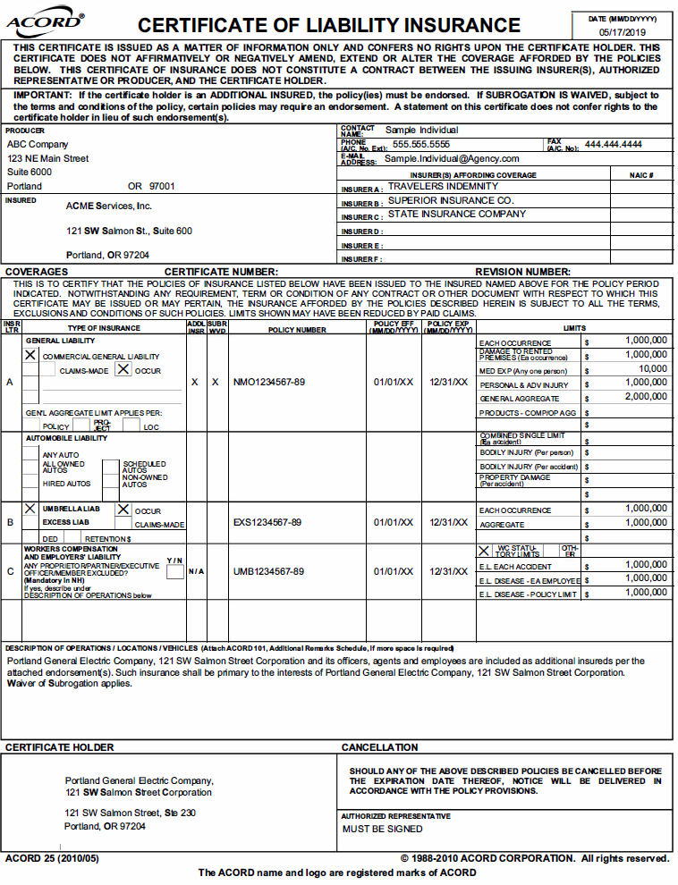

## Moving Guidelines

Due to the heavy use of the freight elevator during business hours, moves are restricted to the hours between 5:30 p.m. and 7:30 a.m. You may also move on weekends and holidays, with no time restrictions. All material, furniture and moving equipment must be removed from elevator lobbies and the freight elevator released by 7:30 a.m. during the business week.

All moves must be coordinated through the Management Office through the Angus work order reservation system. Your freight elevator time will be scheduled so as not to conflict with other moves.

The loading dock is located on 1WTC P1 level which can be accessed by a ramp between First and Second on SW Taylor Street. The height of the entrance is 12’ 6”. Due to the slope of the ramp, long vehicles should be cautious about ceiling clearance at the bottom of the ramp. If trucks are higher than 12” 6” or too long to span the slope change, the offloading will have to take place from the street level. Trucks longer than 30’ should not go into the loading dock. There is a loading zone on 2nd Avenue between SW Taylor and Salmon Streets. Moving over the brick pavers on the plaza level (street level) and the tile between the freight elevator and the carpet on the floor you are accessing requires use of plywood or Masonite to protect the bricks and tile. Please use pneumatic tires. As part of our LEED status, we require that all packing materials be recycled or removed from the property by the moving company. We have a self-serve recycling center located on P1 at One World Trade Center.

**The moving vendor must provide evidence of liability insurance coverage at least five (5) days prior to the day of the move**.

1. Worker’s Compensation: In statutory limits for the state, with employer’s liability of $1,000,000; bodily injury, personal injury and property damage liability insurance in comprehensive general liability form. The certificate of evidence must be furnished to the Management Office before any items can be moved onto the premises.

2. Comprehensive General Liability: Insurance that includes coverage of operation, elevators and products, including personal injury and contractual liability coverage and shall designate the assumptions of liability under performance of the act of moving. Such insurance shall be in limits no less than $2,000,000 per occurrence combined single limit bodily injury or property damage. Property damage insurance shall be in broad form including completed operations.

In addition, the moving vendor must agree to protect, indemnify, and hold the landlord harmless from and against all claims, demands and causes of action of every kind and character, arising in favor of moving vendor’s employees, tenant and its employees, or other third parties due to bodily injury, personal injury, death, or damage to property in any way resulting from willful or negligent acts or omissions on the part of the moving contractor, its agents, employees, representatives, or sub-contractors. The moving vendor shall be responsible for all damages and losses sustained to tools and equipment utilized in the performance of all work thereunder.